**An undertaking of Bhaktapur Municipality**

**KHWOPA COLLEGE OF ENGINEERING**

**(Affiliated to Tribhuvan University)**

**Libali - 8, Bhaktapur**

**Tel: 01-5122098**



**A Final Report**

**On**

**Six Months OJT**

**Prepared By**

Sanjit Kumar Thakur

OJT Trainee

ACKNOWLEDGEMENT

Foremost, I would like to thank the National Examination Board (NEB), Aadarsha Secondary School for including such opportunities in our syllabus. I would like to express my sincere appreciation to Khwopa College of Engineering for providing me with the opportunity to complete my six-month on-the-job training.

I am indebted to Er. Sunil Duwal, Principal, Khwopa College of Engineering (KhCE) for giving me such great opportunity of doing on-the-job training in the college. I am grateful to my mentor, Er. Rabin Dumaru, Er. Suresh Tyata, Er. Anil Tukanbanjar and Er. Shiva Ram Awal, for their guidance and support throughout the training period.

This training experience has been extremely valuable to me, as I have gained valuable knowledge and skills that will be useful in my future professional development. I would also like to thank my colleagues, who have provided me with valuable feedback and support throughout the training period.

Finally, I would also like to thank all the staffs and teachers of Khwopa College of Engineering for their cooperative and helpfulness attitude during my training.

EXECUTIVE SUMMARY

I am honored to present my six-month on-the-job training report, which provides an overview of my experience and the knowledge and skills I have gained during my training period. This training was provided by Khwopa College of Engineering, and it has been an incredible opportunity for me to gain hands-on experience in IT sector.

Throughout the training period, I have had the opportunity to work and learn alongside experienced professionals and learn from their knowledge and expertise. The program provided hands-on exposure to various areas of the IT industry, including software development, network administration, office packages and so on. I have also developed important skills such as problem-solving, communication, and time management. I have been challenged and pushed to grow my skills and knowledge, and I am incredibly grateful for the guidance and support provided by my mentor, Er. Rabin Dumaru, and the entire team at Khwopa College of Engineering.

This report represents the culmination of six months of hard work and dedication, and I hope that it provides valuable insights into the training program and my experience. I would like to express my sincere gratitude to everyone who has supported me throughout this journey and helped me to grow as a professional.

TABLE OF CONTENTS

Chapter Title Page No.

**Acknowledgement II**

**Executive Summary III**

**Table of Contents IV**

**List of Abbreviation V**

**List of Figures VI**

Chapter 1: Introduction 1

1.1 Importance of OJT 1

1.2 Objectives of OJT 2

1.3 Time and Place 2

Chapter 2: OJT Internship Overview 4

Chapter 3: Skills Developed and Tasks Performed 5

3.1 Skills Developed 5

3.2 Tasks Performed 33

Chapter 4: Conclusion and Recommendations 38

4.1 Conclusion 38

4.2 Recommendations 38

Chapter 5: Appendix 39

LIST OF ABBREVIATIONS

**Abbreviation Meaning**

NEB National Examination Board

KhCE Khwopa College of Engineering

IT Information Technology

OJT On-the-Job Training

SQL Structured Query Language

EMIS Education Management Information System

PHP PHP: Hypertext Preprocessor

HTML Hypertext Markup Language

CSS Cascading Style Sheets

VLAN Virtual Local Area Network

DBMS Database Management system

LIST OF FIGURES

Figure 3.1‑1: Mail Merge for Student ID card 6

Figure 3.1‑2: Using VLOOKUP for find final value in different column 7

Figure 3.1‑3: PowerPoint presentation 9

Figure 3.1‑4: Creating Vlan 10,20,30 and data share in same network 10

Figure 3.1‑5: Data share in different network 10

Figure 3.1‑6: Inter Vlan Networking 11

Figure 3.1‑7: Database with 4 tables 14

Figure 3.1‑8: Create Table 14

Figure 3.1‑9: Relation between child class and parent class 15

Figure 3.1‑10: Select 16

Figure 3.1‑11:Inner Join 17

Figure 3.1‑12: Join two tables 17

Figure 3.1‑13: Left Join 18

Figure 3.1‑14: Left Join 18

Figure 3.1‑15: Right Join 18

Figure 3.1‑16: Right Join 18

Figure 3.1‑17: Full Join 18

Figure 3.1‑18: Php syntax 19

Figure 3.1‑19: Variable 19

Figure 3.1‑20: Print 20

Figure 3.1‑21: Echo 20

Figure 3.1‑22: If else loop 21

Figure 3.1‑23: Multidimensional Array 21

Figure 3.1‑24: For loop 22

Figure 3.1‑25: While loop 22

Figure 3.1‑26: Do while loop 22

Figure 3.1‑27: Foreach loop 22

Figure 3.1‑28: Exception Handling 24

Figure 3.1‑29: Database connect 24

Figure 3.1‑30: Dashboard Cleaning and Project Folder 25

Figure 3.1‑31: Database Module 26

Figure 3.1‑32: Login page 28

Figure 3.1‑33: Dashboard clean 28

Figure 3.1‑34: Category List 29

Figure 3.1‑35: Add Category Dialog 29

Figure 3.1‑36: Git Cheat Code 30

Figure 3.1‑37: Static website 31

Figure 3.2‑1: Letter Forwarding 34

Figure 3.2‑2: Attendance Taking 35

Figure 3.2‑3: Attendance check 35

Figure 3.2‑4: Final Result Preparation 36

Figure 3.2‑5: Create Teams 37

Figure 3.2‑6: Priority form 37

# Introduction

On the Job Training is a part of college curriculum that aims to train and orient students about the work and their future career. It is a type of skills development program where trainee learns how to do the work through hands-on experience. This will help the students to expose with different work situation to give students an opportunity experience and to apply their knowledge that they learned from school. It also helps students to acquire relevant knowledge and skills by performing in actual work settings.

OJT is important not only to teach students regarding their chosen career but also to show students the reality about working. The students will be exposed to the actual work related to the course that they are taking. On-the-job training isn’t always standard practice, but it can increase productivity and efficiency. Not only that, but it can also benefit the company as a whole, from reducing training costs to creating more effective, motivated employees. There are many methods of OJT training, but they all share one common goal: to help employees learn the specific skills and knowledge they need to perform their job duties more effectively.

## Importance of OJT

OJT is a part of college curriculum that aims to train and orient students about the work and their future career. The training provides students the opportunity to gain sufficient knowledge and skills relevant to work habits necessary to become competitive in the future.

* OJT allows students to learn in a real-work environment, which can help them better understand the practical applications of their new skills.
* OJT allows students to learn at their own pace, which can make the learning process more effective and efficient.
* OJT can be customized to meet the specific needs and goals of the student and the organization.
* OJT can be a cost-effective way to train students, as it requires minimal investment in terms of resources and time.
* OJT can improve student retention, as students who feel invested in and supported by their organization are more likely to stay with the company.
* OJT can help organizations stay competitive by ensuring that their students have the skills and knowledge they need to succeed in their roles.

Overall, OJT is an important part of student development and can have a positive impact on the success of both the student and the organization.

## Objectives of OJT

The objectives of OJT can vary depending on the needs and goals of the student and the organization. Some common objectives of OJT include:

* To teach students new skills, knowledge, and behaviors that will enable them to perform their job tasks more effectively.
* To improve the efficiency and productivity of students by helping them learn new processes and techniques.
* To develop the competencies of students and help them advance in their careers.
* To increase student satisfaction and motivation by providing opportunities for learning and development.

Overall, the objectives of OJT are to help students learn and develop new competencies that will enable them to perform their job tasks more effectively and contribute to the success of the organization.

## Time and Place

After completing our +2 from Adarsha Secondary School, we started our (OJT) as required by our syllabus in Khwopa College of Engineering (KhCE), Liwali-8, Bhaktapur. We started our OJT session from 26th Asar, 2079 to Mangsir, 2079.

KhCE is community-based engineering college, undertaken by Bhaktapur Municipality. It is centrally located at culturally rich city Bhaktapur. KhCE will, in every regard, be the right destination for those who aspire to become professional engineers at affordable fees. With a distant vision of maintaining Bhaktapur's hard-won glory, the college aims to produce highly skilled engineers that will have blends of both indigenous and modern-day technologies. In this regard, the college is aiming to provide quality education in the engineering in the engineering fields which are of prime importance for the development of country.

**Vision and Mission of KhCE**

**Vision:** To boost the development of Nepal's ancient city, Bhaktapur a Center of Excellence with sound academic atmosphere and profound quality educational opportunities for the common people of Nepal in the field of science and technology for the improvement of the quality of life.

**Mission:** KhCE is committed to a nurturing approach for education and faith formation. KhCE devotedly embraces this approach for students, faculty, and staff to serve the country and people.

The major approaches for accomplishing the mission are as follows:

1. Provide a dedicated approach to education to serve the country and people.
2. Intellectualize society by providing quality education at an affordable fee.
3. Provide quality education in order to preserve the lively traditional art and culture of Bhaktapur and country at large.
4. Encourage leadership, active learning, critical thinking, and technological skills to lead the engineering field and accept the challenges of the 21st century.
5. Hold faculty and students alike to the high standards of intellectual and moral development.

# OJT Internship Overview

Our role at Khwopa College of Engineering (KhCE) was to work with an IT Engineer sir. We strictly needed to follow the college time i.e., from morning 10:45 AM to 5:45 PM in the summer and 10:45 AM to 5:00 PM in winter. Our shift was primarily divided into two parts, the first being to perform the college tasks and second shift to learn new skills.

We started learning from the very basic i.e., typing practice, Word, Excel, PowerPoint. We spend our first month learning these much-needed skills then we slowly started learning our course related skills. We learnt and practiced the MySQL database (database creation, table creation, relation between the tables, SQL queries and so on). We almost spend 1 month in learning the database as it’s very much the first step towards coding. Later, we started learning coding, mainly PHP and worked on template. Other than these, we also developed skill on networking (RJ 45 connection, Cisco Design, File Sharing), computer hardware (adding new hard disk, RAM replace, power supply, etc.).

As for the tasks, we started our OJT with document scanning of students and uploading it to the EMIS system. We regularly work in the Labs to install the required software’s and OS and even activate the OS and Office. We also collected all the final result from batch 2066 and modified the result as per the format given by teacher and made it ready to be uploaded into EMIS system. We were able to see how android apps are developed and kept in the google play store. We performed QA testing on KhEC EMIS app and report all the bugs.

# Skills Developed and Tasks Performed

There are many skills that can be developed through on-the-job training (OJT). Some of the skills that may be developed include:

* Technical skills: OJT can be an effective way for employees to learn and develop specific technical skills related to their job tasks. This can include learning how to operate equipment, use software programs, or follow specific procedures.
* Interpersonal skills: OJT can also help employees develop their interpersonal skills, such as communication, teamwork, and problem-solving.
* Leadership skills: OJT can provide opportunities for employees to take on leadership roles, such as training new employees or leading projects. This can help employees develop leadership skills and confidence.
* Time management skills: OJT can help employees learn how to manage their time effectively and prioritize their tasks.
* Adaptability: OJT can also help employees develop their adaptability and flexibility, as they may be required to learn and adapt to new processes and procedures.

## Skills Developed

We mainly focused on developing technical skills. We spend our OJT learning and developing the following skills.

1. Report Writing (Word)
2. Manipulation of Data (Excel)

* format, organize and calculate data in a spreadsheet.

1. Presentation (PowerPoint)

* Communicate with the audience through graphics, text or videos.

1. Networking (Cisco)
2. Google Form
3. Database Design
4. Git
5. Coding (PHP, HTML, CSS, Cisco)
6. Mathematics Session
7. **Microsoft word**

Microsoft Word is a word processing software that allows users to create and edit documents. We learnt about:

* Basics of Word
* Report Structure
* Formatting
* Referencing and so on.

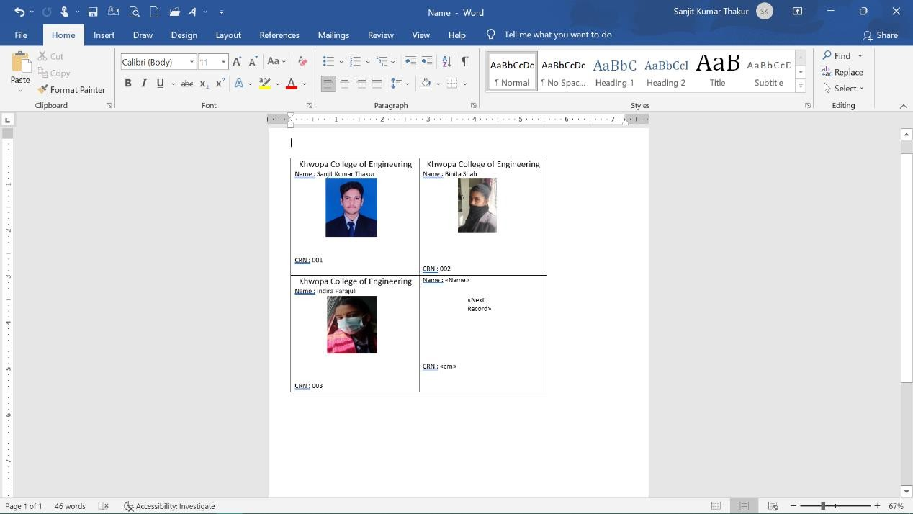Along with this, we also learnt about Mail Merge. We practiced mail merge by creating students’ ID card.

Figure 3.1‑1: Mail Merge for Student ID card

Basic features of Microsoft Word that we practiced are listed below:

* Formatting text, including bold, italic, and underline
* Adding and formatting headings and subheadings
* Creating and formatting lists, including numbered and bullet points
* Adding and formatting tables
* Inserting and formatting images and other media
* Setting margins and page orientation
* Using spell check and grammar check
* Referencing
* Mail Merge

Usage

* Preparation of Report i.e., monthly reports, final report
* ID Card creation using mail merge.

1. **Microsoft excels**

Microsoft Excel is a spreadsheet software that allows users to organize, format, and calculate data. We learnt the basic of Excel and the different use of formulas needed to modify the documents. Some important formulas are:

1. VLOOKUP
   * + Click the cell where you want the VLOOKUP formula to be calculated.
     + Click Formulas at the top of the screen.
     + Click Lookup & Reference on the Ribbon.
     + Click VLOOKUP at the bottom of the drop-down menu.
     + Specify the cell in which you will enter the value whose data you're looking for.

Syntax: VLOOKUP (lookup_value,table_array,col_index_num,[range_lookup])

Figure 3.1‑2: Using VLOOKUP for find final value in different column

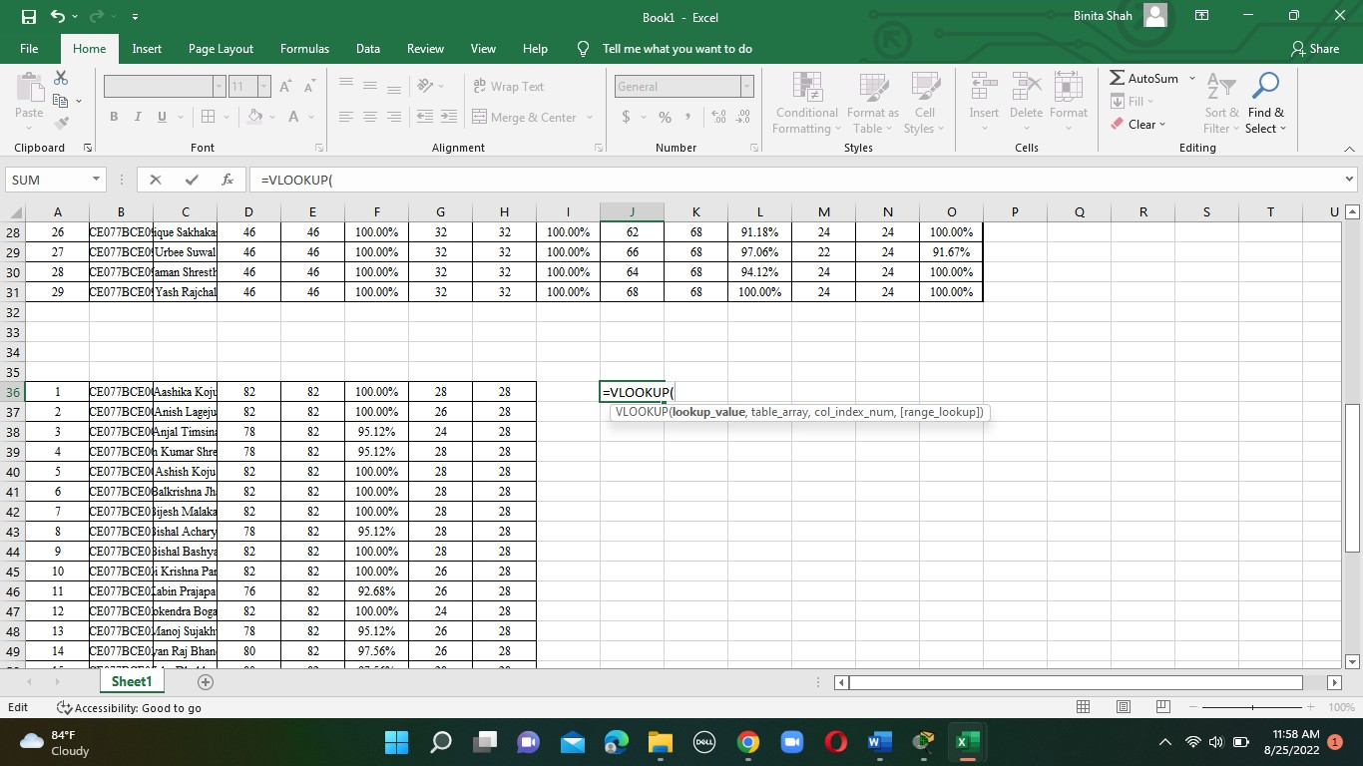

1. If Function

Use the IF function, one of the logical functions, to return one value if a condition is true and another value if it's false. For example: =IF(A2>B2,"Over Budget","OK")

=IF (A2=B2, B4-A4,"")

1. PROPER Function

The PROPER Function [1] is categorized under Excel Text functions. PROPER will capitalize the first letter in a text string and any other letters in text that follow any character other than a letter.

1. UPPER Function

Use =UPPER(A2) in cases where you need to convert text to uppercase, replacing A2 with the appropriate cell reference. Now, fill down the formula in the new column. The quickest way to do this is by selecting cell B2, and then double-clicking the small black square that appears in the lower-right corner of the cell.

Some basic features of Microsoft Excel that we practiced are:

* Entering and editing data in cells
* Using formulas and functions to perform calculations
* Formatting cells, including aligning text, changing fonts and font sizes, and setting cell borders and colors
* Creating charts and graphs to visualize data
* Using pivot tables to summarize and analyze large sets of data
* Sorting and filtering data to find specific information
* Protecting worksheets and cells to prevent accidental or unauthorized changes
* Collaborating with others by tracking and reviewing changes made by multiple user

1. **Microsoft PowerPoint**

Microsoft PowerPoint is a presentation software that allows users to create and edit slide decks and multimedia presentations. We learnt about layout, design and some part of animation, to link the content to required area and so on. We were also introduced about how to macro code with an example (only introduced not learnt). At the same time, we also learnt about Google Forms and its application. Here is a snippet of form we prepared.



Figure 3.1‑3: PowerPoint presentation

Some specific features of Microsoft PowerPoint that are commonly used include:

* Creating and formatting slides with text, images, and other media
* Adding transitions and animations between slides
* Inserting and formatting shapes and diagrams
* Creating and formatting tables and charts
* Adding and customizing slide backgrounds
* Inserting and playing media such as audio and video
* Collaborating with others by tracking and reviewing changes made by multiple users
* Delivering presentations in person or remotely, such as through a video conference.

1. **Cisco Design**

In Cisco, we learnt about vlan & its creation, data sharing in same network, intel vlan networking and so on.

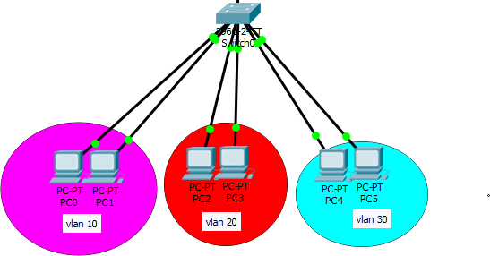

Figure 3.1‑4: Creating Vlan 10,20,30 and data share in same network

* Vlan 10: private subnet=192.168.10.0/24.
* Vlan 20: private subnet=192.168.20.0/24.
* Vlan 30: private subnet=192.168.30.0/24.

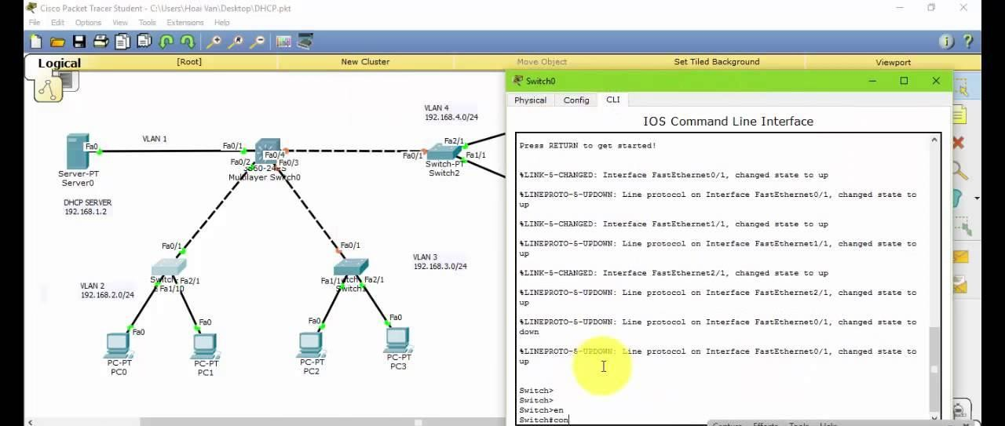

Figure 3.1‑5: Data share in different network

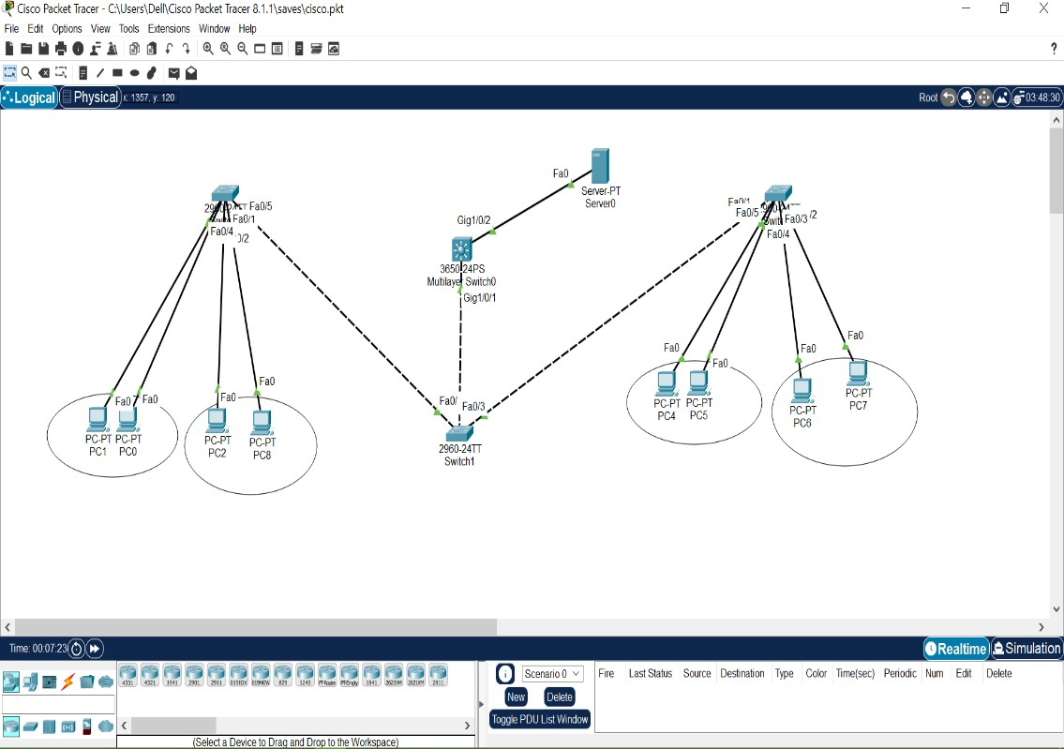

Figure 3.1‑6: Inter Vlan Networking

1. **RJ-45 Ethernet cable connection**

An RJ-45 Ethernet cable is a type of network cable that is commonly used to connect devices to a local area network (LAN). The cable has an RJ-45 connector on each end, which is a 8-pin connector that is used to transmit data over Ethernet.

To make an Ethernet connection using an RJ-45 cable, we need two devices that are equipped with Ethernet ports, such as a computer and a router. We also need an Ethernet cable with RJ-45 connectors on both ends.

1. **Shared file by using IP address in same network**

To share a file using an IP address in the same network, we will need to use a network sharing protocol such as SMB (Server Message Block) or NFS (Network File System). These protocols allow us to access and share files over a network by using the IP address of the device on which the file is stored.

Here's an example of how you can share a file using SMB on a Windows computer:

1. Open the folder that contains the file we want to share.
2. Right-click on the file and select "Properties."
3. In the Properties window, go to the "Sharing" tab.
4. Click the "Advanced Sharing" button.
5. In the Advanced Sharing window, check the box next to "Share this folder."
6. Click the "Permissions" button to set the permissions for the shared folder.
7. Click "OK" to close the Advanced Sharing window.
8. To access the shared file from another device on the same network, open a file explorer window on the other device and enter the IP address of the device that is sharing the file followed by the name of the shared folder (e.g., \192.168.0.100\sharedfolder).

We will be prompted to enter a username and password to access the shared folder. If the sharing device is running Windows, we can use our Windows login credentials. If the sharing device is running a different operating system, we may need to use a different set of credentials.

Once we have accessed the shared folder, we can copy, delete, or modify the files as needed.

1. **Shared printer in network**

To share a printer in a network, we will need to connect the printer to a computer or a network device that is acting as a print server. We can then use the print server to share the printer with other devices on the network.

Here's how we can share a printer in a Windows network:

1. Connect the printer to the print server using a USB cable or an Ethernet cable.
2. On the print server, go to the "Control Panel" and select "Hardware and Sound," then "Devices and Printers."
3. Right-click on the printer that you want to share and select "Printer properties."
4. In the Printer Properties window, go to the "Sharing" tab.
5. Check the box next to "Share this printer."
6. Enter a share name for the printer. This is the name that other devices on the network will use to access the printer.
7. Click "OK" to save the changes.
8. To access the shared printer from another device on the network, go to the "Control Panel" and select "Hardware and Sound," then "Devices and Printers."
9. Click the "Add a printer" button.
10. In the Add Printer wizard, select "Add a network, wireless or Bluetooth printer."
11. Follow the prompts to search for and select the shared printer.

Once we have added the shared printer to our device, we can use it just like any other printer. We can print documents, photos, and other files to the shared printer from any device on the network.

1. **Google Form**

Google Forms is a free online survey tool that is part of the Google Workspace (formerly Google Docs) productivity suite. With Google Forms, we can create surveys, quizzes, and other types of forms and share them with others. We can also use Google Forms to collect and analyze responses in real-time.

To create a Google Form, we will need to follow these steps:

1. Go to the Google Forms website (https://www.google.com/forms/) and sign in with our Google account.
2. Click the "New Form" button to create a new form.
3. Give our form a title and add a description if desired.
4. Click the "Add a question" button to add questions to our form.
5. Select the type of question we want to add (e.g., multiple choice, short answer, etc.).
6. Enter the question text and any additional options or settings as needed.
7. Repeat steps 4-6 to add more questions to our form.
8. When we are finished, click the "Send" button to share our form with others.

We can share our form via a link, email, or by embedding it on a website. We can also use the Form Responses tab to view and analyze the responses to our form in real-time. Google Forms is a powerful and easy-to-use tool for creating and sharing surveys, quizzes, and other types of forms. It is widely used for a variety of purposes, including market research, customer feedback, and event registration.

1. **Database**

A database is an organized collection of structured information, or data, typically stored electronically in a computer system. A database is usually controlled by a database management system (DBMS).

We learnt and performed different queries in database. We created database “company” with 4 tables namely employee, department, location and job. We practiced all the below mentioned operations within the created database. Some basic operations performed are shown below:

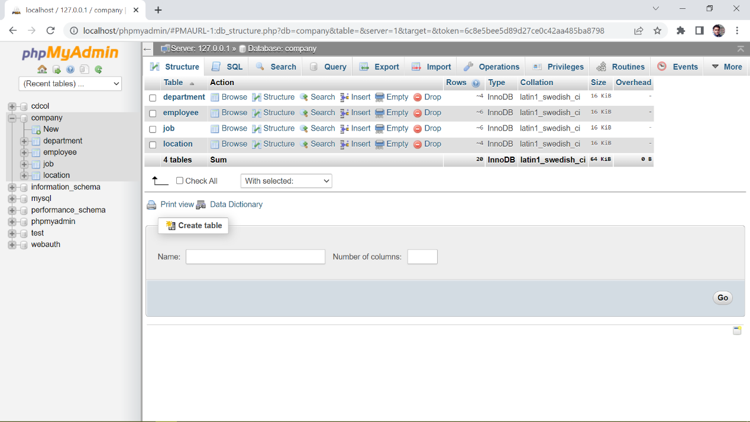

Figure 3.1‑7: Database with 4 tables

1. **Create Database**

The CREATE DATABASE statement is used to create a new SQL database.

CREATE DATABASE KhEC;

1. **Create Table**

The CREATE TABLE statement is used to create a new table in a database.

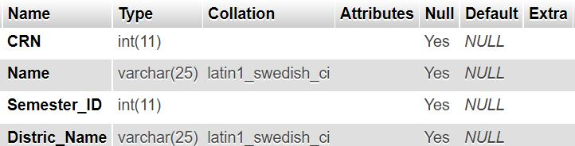

CREATE TABLE student_data (

CRN int,

Name varchar(25),

Semester_ID int,

Distric_Name varchar(25)

Figure 3.1‑8: Create Table

);

1. **Drop Table**

The DROP TABLE statement is used to drop an existing table in a database.

DROP TABLE table_name;

1. **Primary Key**

The PRIMARY KEY constraint uniquely identifies each record in a table.

Primary keys must contain UNIQUE values, and cannot contain NULL values.

CREATE TABLE Persons (

ID int NOT NULL,

LastName varchar(255) NOT NULL,

FirstName varchar(255),

Age int,

PRIMARY KEY (ID)

);

1. **Foreign Key**

The FOREIGN KEY constraint is used to prevent actions that would destroy links between tables.

A FOREIGN KEY is a field (or collection of fields) in one table, that refers to the PRIMARY KEY in another table.

**Relation Between Child class and Parents class**

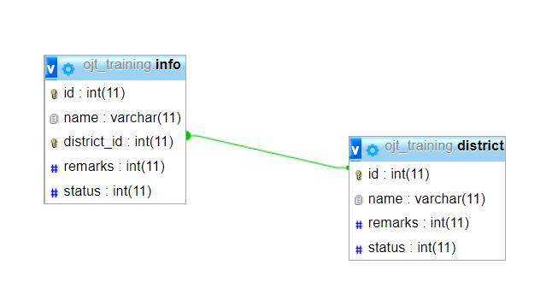A parent can be a child in another relationship. A parent class instance can exist without a child class instance. Every child class has only one parent class, but a parent class can have more than one child class. In terms of databases, a parent class has a one-to-many relationship with a child class.

Figure 3.1‑9: Relation between child class and parent class

**CRUD Operation**

CRUD is an acronym that comes from the world of computer programming and refers to the four functions that are considered necessary to implement a persistent storage application: create, read, update and delete.

* CREATE procedures generate new records via INSERT statements
* READ procedures reads the data based on input parameters. Similarly, RETRIEVE procedures grab records based on input parameters
* UPDATE procedures modify records without overwriting them
* DELETE procedures delete where specified

1. **Select**

The SELECT statement is used to select data from a database.

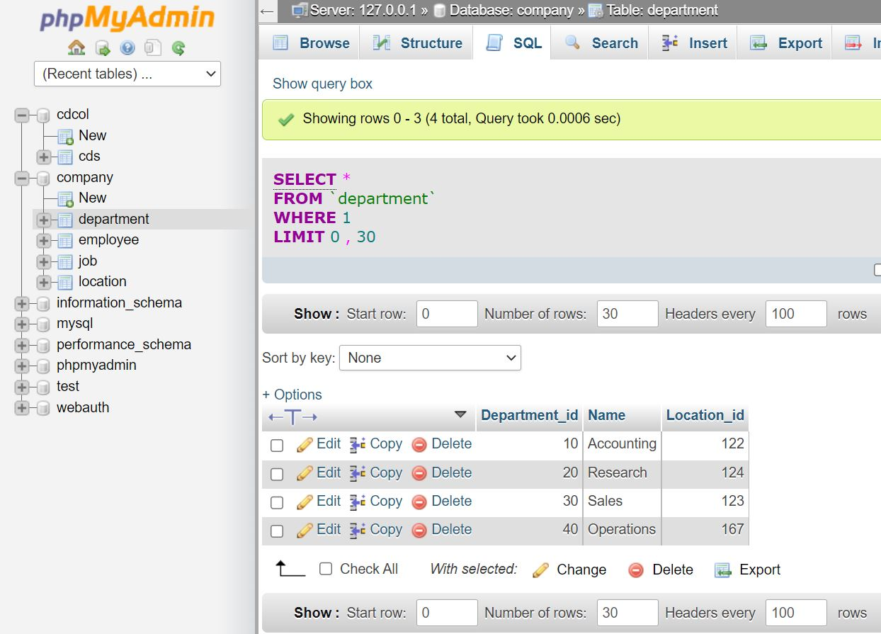

Figure 3.1‑10: Select

SELECT column1, column2, ...

FROM table_name;

1. **Insert**

The INSERT INTO statement is used to insert new records in a table.

INSERT INTO table_name (column1, column2, column3, ...)

VALUES (value1, value2, value3, ...);

1. **UPDATE**

The UPDATE statement is used to modify the existing records in a table.

UPDATE table_name

SET column1 = value1, column2 = value2, ...

WHERE condition;

1. **DELETE**

The DELETE statement is used to delete existing records in a table.

DELETE FROM table_name WHERE condition;

**AGGREGATE Functions**

1. **MIN() and MAX() Functions**

The MIN() function returns the smallest value of the selected column.

SELECT MIN(column_name)

FROM table_name

WHERE condition;

Similarly, the MAX() function returns the largest value of the selected column.

1. **COUNT(), AVG() and SUM() Functions**

The COUNT() function returns the number of rows that matches a specified criterion. The AVG() function returns the average value of a numeric column and The SUM() function returns the total sum of a numeric column.

**Join**

A JOIN clause is used to combine rows from two or more tables, based on a related column between them.

SELECT table1.column1,table1.column2,table2.column1,....

FROM table1

JOIN table2

ON table1.matching_column = table2.matching_column;

1. 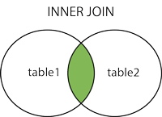**Inner Join**

Returns records that have matching values in both tables.

SELECT table1.column1,table1.column2,table2.column1,....

FROM table1

INNER JOIN table2

ON table1.matching_column = table2.matching_column;

Figure 3.1‑11:Inner Join

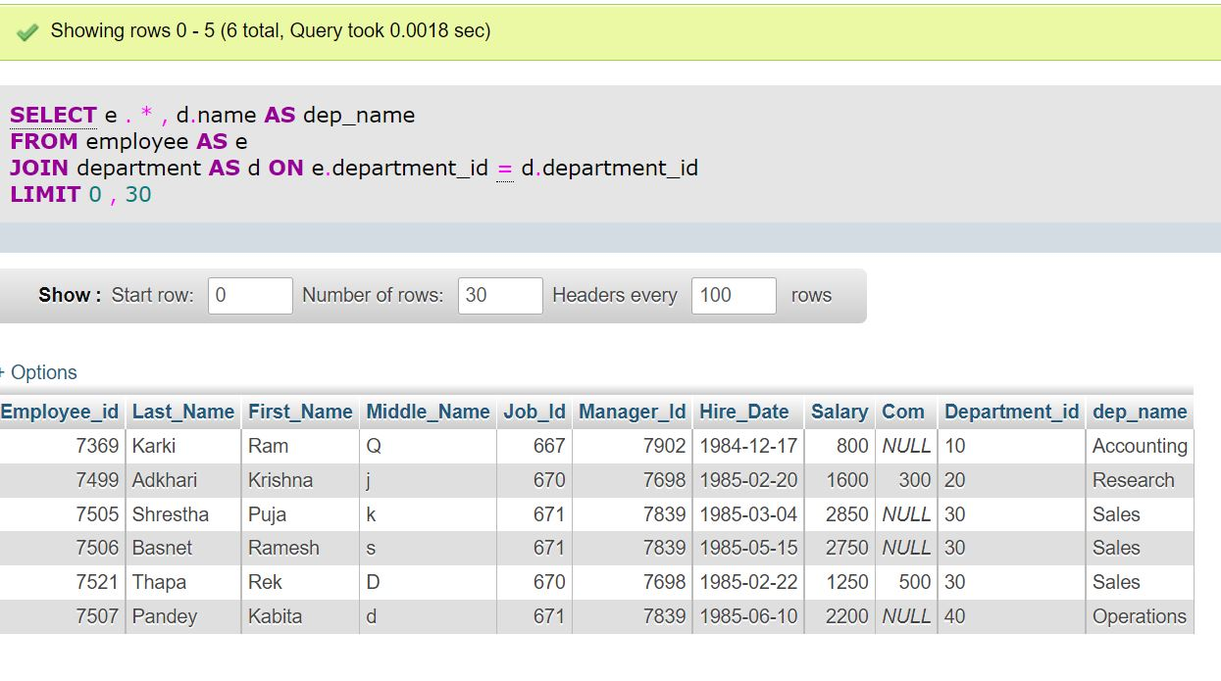

Figure 3.1‑12: Join two tables

Example:

SELECT e.*, d.name as dep_name

FROM employee as e

JOIN department as d ON e.department_id=d.department_id;

1. **Left Join**

Returns all records from the left table, and the matched records

 from the right table.

SELECT e. * , d.name AS dep_name

FROM employee AS e

LEFT JOIN department AS d

ON e.department_id = d.department_id;

Figure 3.1‑13: Left Join

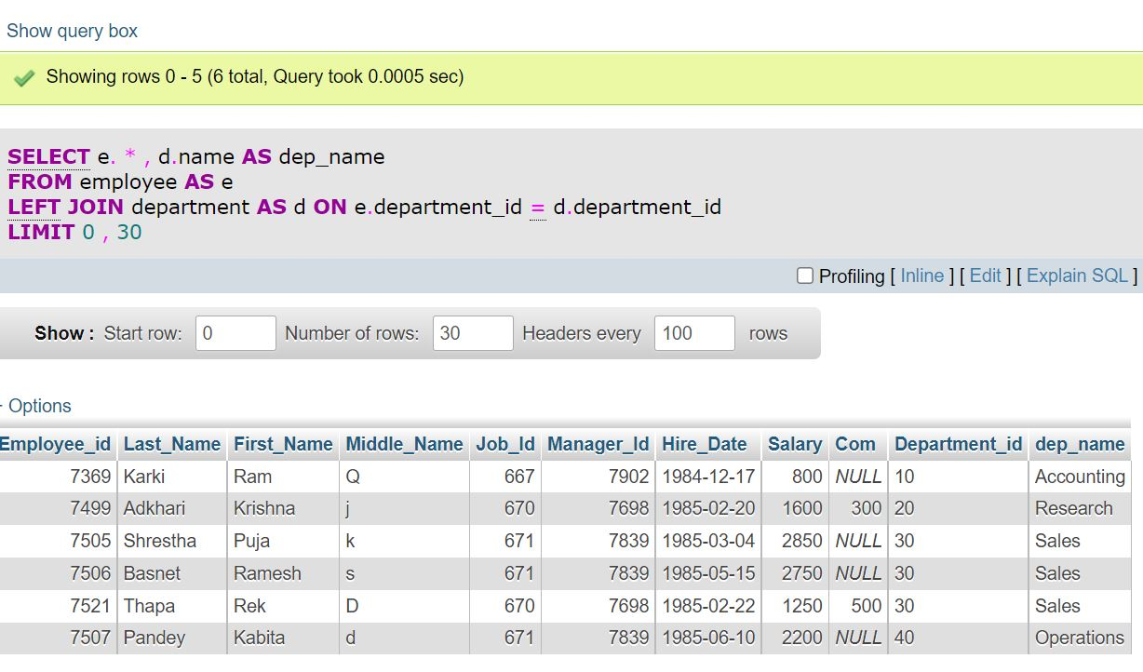

Figure 3.1‑14: Left Join

1. **Right Join**

Returns all records from the right table, and the matched records from the left table.

Figure 3.1‑15: Right Join

SELECT e. * , d.name AS dep_name

FROM employee AS e

Right JOIN department AS d

ON e.department_id = d.department_id;

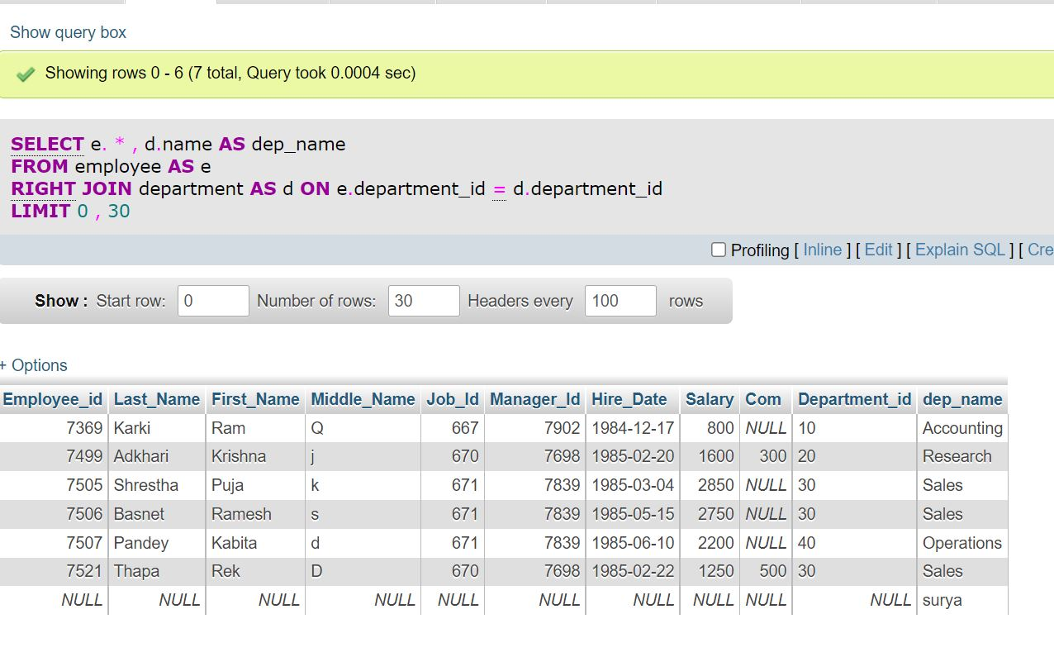

Figure 3.1‑16: Right Join

1. **Full Join**

Returns all records when there is a match in either left or right table.

SELECT table1.column1,table1.column2,table2.column1,....

FROM table1

Figure 3.1‑17: Full Join

FULL JOIN table2

ON table1.matching_column = table2.matching_column;

**Group By**

The GROUP BY statement groups rows that have the same values into summary rows, like "find the number of customers in each country".

The GROUP BY statement is often used with aggregate functions (COUNT(), MAX(), MIN(), SUM(), AVG()) to group the result-set by one or more columns.

SELECT column_name(s)

FROM table_name

WHERE condition

GROUP BY column_name(s)

ORDER BY column_name(s);

1. **Coding (Php)**

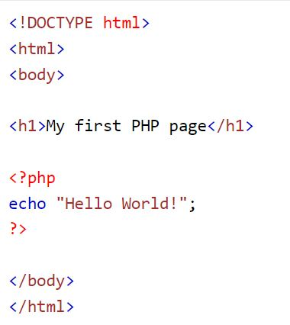We started through the overview of the PHP and then started with the syntax of the language. As we needed to execute the code to check the output, we preferred to use Xampp server. We learnt where to store our repository and from where to access them. Then formally we started learning PHP.

**Php Basic**

1. Php Syntax

A PHP script starts with <?php and ends with ?>:

<?php

// PHP code goes here

Figure 3.1‑18: Php syntax

?>

1. Variables, Echo and Print

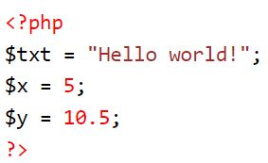In PHP, a variable starts with the $ sign, followed by the name of the variable:

<?php

$txt = "Hello world!";

$x = 5;

$y = 10.5;

?>

Figure 3.1‑19: Variable

Echo and Print are more or less the same. They are both used to output data to the screen.

The differences are small: echo has no return value while print has a return value of 1 so it can be used in expressions. echo can take multiple parameters (although such usage is rare) while print can take one argument. echo is marginally faster than print.

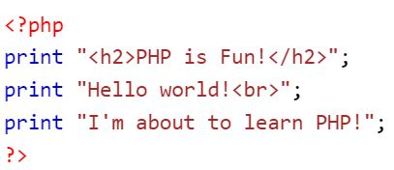<?php

Figure 3.1‑20: Print

print "<h2>PHP is Fun!</h2>";

print "Hello world!<br>";

print "I'm about to learn PHP!";

?>

<?php

echo "<h2>PHP is Fun!</h2>";

echo "Hello world!<br>";

echo "I'm about to learn PHP!<br>";

echo "This ", "string ", "was ", "made ", "with multiple parameters.";

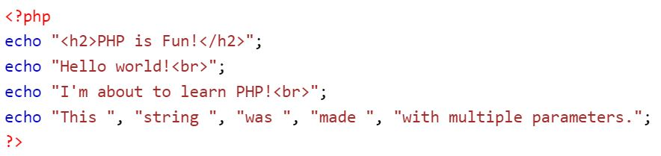?>

Figure 3.1‑21: Echo

**Data types**

Variables can store data of different types, and different data types can do different things.

PHP supports the following data types:

* String
* Integer
* Float (floating point numbers - also called double)
* Boolean
* Array
* Object
* NULL
* Resource

**Operator, Conditional Statement**

Operators are used to perform operations on variables and values.

Conditional statements are used to perform different actions based

on different conditions.

In PHP we have the following conditional statements:

* if statement - executes some code if one condition is true
* if...else statement - executes some code if a condition is true and another code if that condition is false
* if...elseif...else statement - executes different codes for more than two conditions
* switch statement - selects one of many blocks of code to be executed

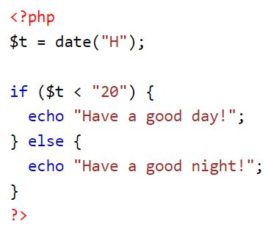

Figure 3.1‑22: If else loop

**Array & its types**

An array is a special variable, which can hold more than one value at a time.

In PHP, there are three types of arrays:

* Indexed arrays - Arrays with a numeric index
* Associative arrays - Arrays with named keys
* Multidimensional arrays - Arrays containing one or more arrays

<?php

$cars = array("Volvo", "BMW", "Toyota");

echo count($cars);

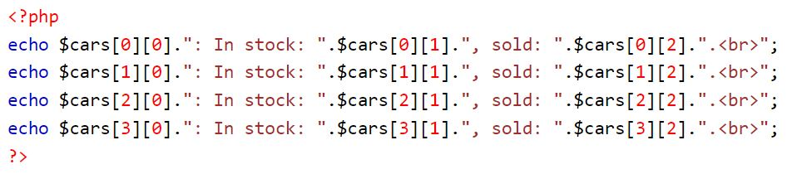?>

Figure 3.1‑23: Multidimensional Array

**Loop and Functions**

Loops in PHP are used to execute the same block of code a specified number of times. PHP supports following four loop types.

1. 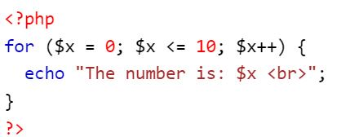for − loops through a block of code a specified number of times.

Figure 3.1‑24: For loop

1. while − loops through a block of code if and as long as a specified condition is true.

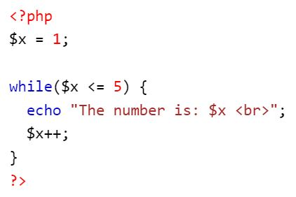

Figure 3.1‑25: While loop

1. 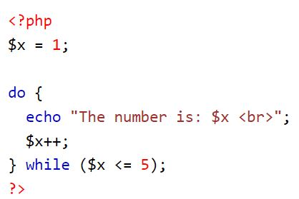do...while − loops through a block of code once, and then repeats the loop as long as a special condition is true.

Figure 3.1‑26: Do while loop

1. 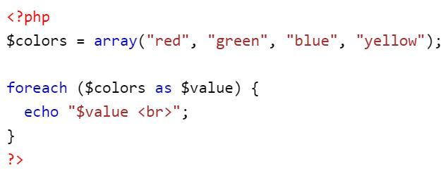foreach − loops through a block of code for each element in an array.

Figure 3.1‑27: Foreach loop

PHP functions are similar to other programming languages. A function is a piece of code which takes one more input in the form of parameter and does some processing and returns a value.

<?php

/* Defining a PHP Function */

function writeMessage() {

echo "You are really a nice person, Have a nice time!";

}

/* Calling a PHP Function */

writeMessage();

?>

**Super Global Variable, Datetime**

Some predefined variables in PHP are "superglobals", which means that they are always accessible, regardless of scope - and you can access them from any function, class or file without having to do anything special.

The PHP superglobal variables are:

* $GLOBALS
* $_SERVER
* $_REQUEST
* $_POST
* $_GET
* $_FILES
* $_ENV
* $_COOKIE
* $_SESSION

The PHP date() function is used to format a date and/or a time.

date(format,timestamp)

**Session & Cookie**

A session is a way to store information (in variables) to be used across multiple pages.

<?php

// Start the session

session_start();

$_SESSION["favcolor"] = "green";

$_SESSION["favanimal"] = "cat";

echo "Session variables are set.";

?>

A cookie is often used to identify a user. A cookie is a small file that the server embeds on the user's computer.

setcookie(name, value, expire, path, domain, secure, httponly);

**Exception Handling**

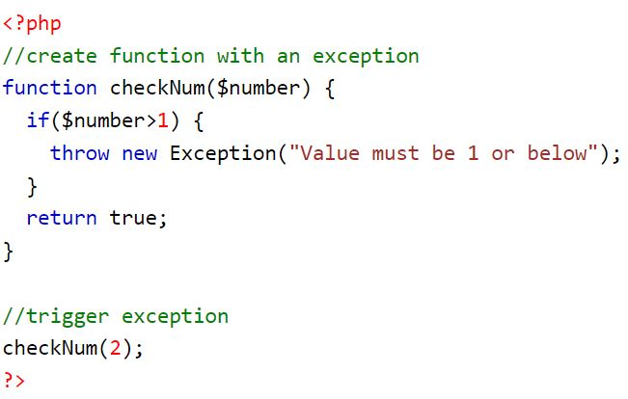Exceptions are used to change the normal flow of a script if a specified error occurs.

Figure 3.1‑28: Exception Handling

**Database and MySQL**

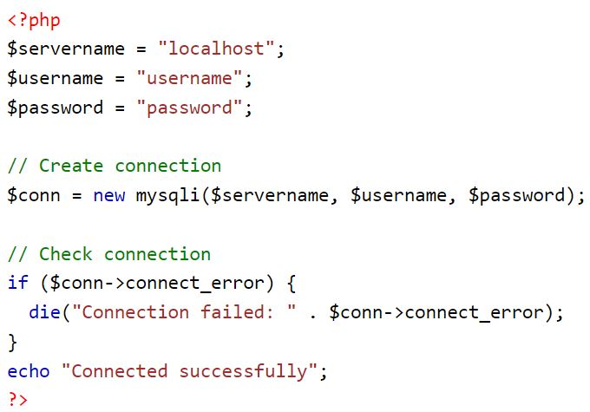The data in a MySQL database are stored in tables. A table is a collection of related data, and it consists of columns and rows.

Figure 3.1‑29: Database connect

**Dashboard Cleaning and Project Folder Configuration**

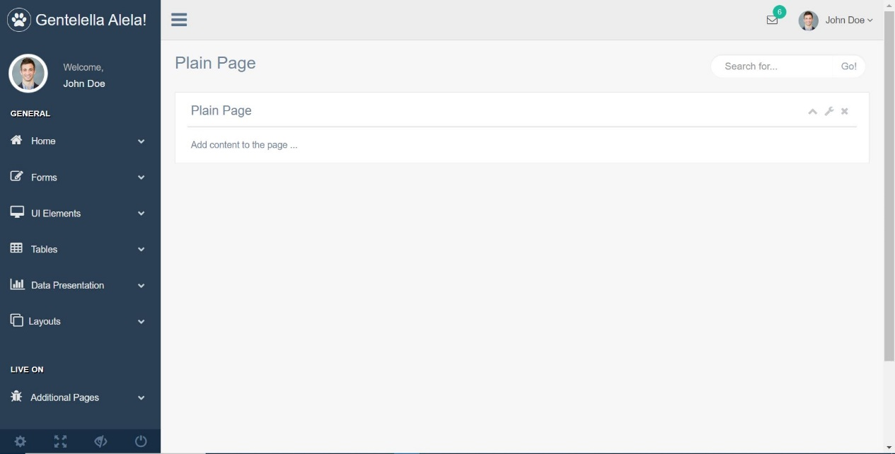After being familiar with PHP, we downloaded the ready to use template to practice and develop a system. As the template has lots of files and features, it was necessary to clean the template and modify to our requirement.

Figure 3.1‑30: Dashboard Cleaning and Project Folder

For this, we deleted the unnecessary files and modified the Xampp configuration to get the final template output.

**Database Module**

A database module is a software component that provides access to a database management system (DBMS) and enables users to interact with the database. The setup of a database module typically involves installing the necessary software and libraries, configuring the module to connect to the DBMS, and testing the connection to ensure that the module is working properly.

To set up a database module, we performed the following steps:

* + 1. Install the necessary software and libraries: Depending on the database module we are using, we installed specific software and libraries in order to use it. For example, we are using a PHP database module, we installed relevant libraries and software called Xampp.
    2. Configure the database module: Once the necessary software and libraries were installed, we need to configure the database module to connect to the DBMS. This typically involves specifying the hostname or IP address of the database server, the port number, the database name, and the authentication credentials (such as the username and password) needed to access the database. For this, we created configuration.php file and defined DB_HOST, DB_NAME, ERROR_PATH, CLASS_PATH, CONFIG_PATH and so on.
    3. Test the connection: After configuring the database module, we test the connection to ensure that it is working properly. This may involve running a simple script or command that attempts to connect to the database and perform a basic operation, such as querying the database or inserting data into a table.

Overall, setting up a database module involves installing the necessary software and libraries, configuring the module to connect to the DBMS, and testing the connection to ensure that it is working properly. This allows you to use the database module to interact with the database and perform various operations, such as querying and modifying data

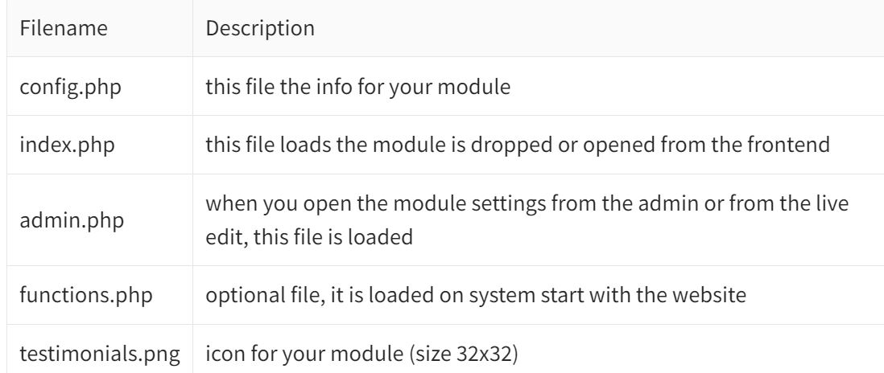

Figure 3.1‑31: Database Module

**Database module generate SQL**

PHP database module have the ability to generate SQL (Structured Query Language) statements based on user input or other criteria.

SQL is the standard language for interacting with relational databases, and is used to perform various operations such as querying data, inserting, updating, and deleting records, and creating and modifying database objects such as tables and views. Generating SQL statements using a database module can be useful in a variety of scenarios, such as when you want to automate the generation of complex or repetitive SQL queries, or when you want to generate SQL statements based on user input or other data.

To generate SQL statements using a database module, we would typically need to use the relevant functions and methods provided by the module. For example, we are using a Php database module, we use the generate_sql() method to generate an SQL statement based on input parameters such as the table name, the columns to be selected, and the conditions for the WHERE clause.

We have created no. of modules to automate operations like runQuery to run the sql statements and return the values, addData to insert data into table, getData to return data of the query, updateData, deleteData and so on.   
Basically, we have created modules to automate the CRUD operations in the database.

Overall, the ability to generate SQL statements using a database module can be useful for automating the generation of complex or repetitive SQL queries, and for generating SQL statements based on user input or other data. This can save time and effort, and make it easier to interact with the database using SQL.

**Session Login**

To implement a session-based login system using PHP, we performed the following steps:

1. Configure the PHP session: The first step is to configure the PHP session by calling the session_start() function. This function initializes a session and generates a unique session ID, which is used to identify the user throughout the session.
2. Authenticate the user: Next, we authenticate the user by checking their username and password against the credentials stored in the database. If the credentials are valid, we store the user's information (such as their name and email address) in the session variables, which can be accessed by other pages during the session.
3. Redirect the user: After the user has been authenticated, we redirect them to the appropriate page or pages based on their role or permissions. For example, if the user is an admin, we redirect them to the admin dashboard, whereas if they are a regular user, we redirect them to the user profile page.
4. Check for a valid session: On each subsequent page that the user accesses during the session, we check if the session is valid by checking if the session variables are set. If the session variables are not set, it means that the user is not logged in and we need to redirect them to the login page.

Overall, implementing a session-based login system using PHP involves configuring the PHP session, authenticating the user, redirecting the user to the appropriate page, and checking for a valid session on each subsequent page. This allows you to maintain the user's login status throughout the session and provide them with the appropriate access to pages and resources based on their role and permissions.

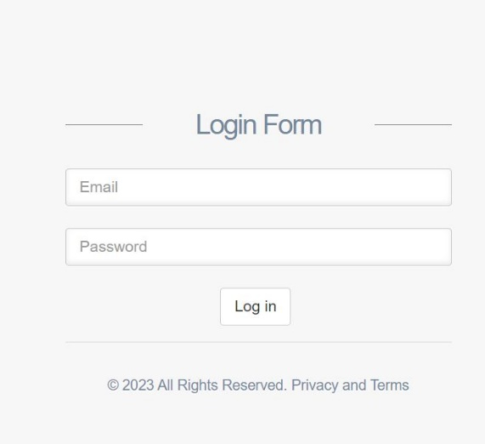Following the above learnt coding, we worked on a ready to use template and performed different tasks in the template such as dashboard cleaning, login method using session and cookie, crud operation, UI designs and so on.

Figure 3.1‑32: Login page

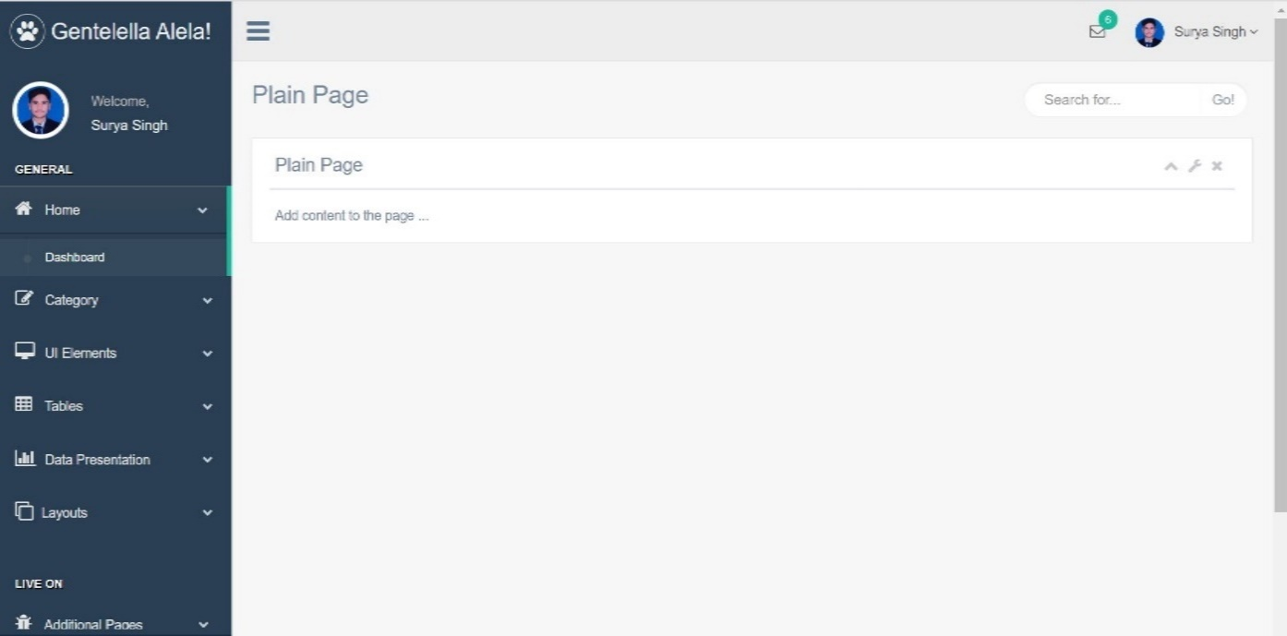

Figure 3.1‑33: Dashboard clean

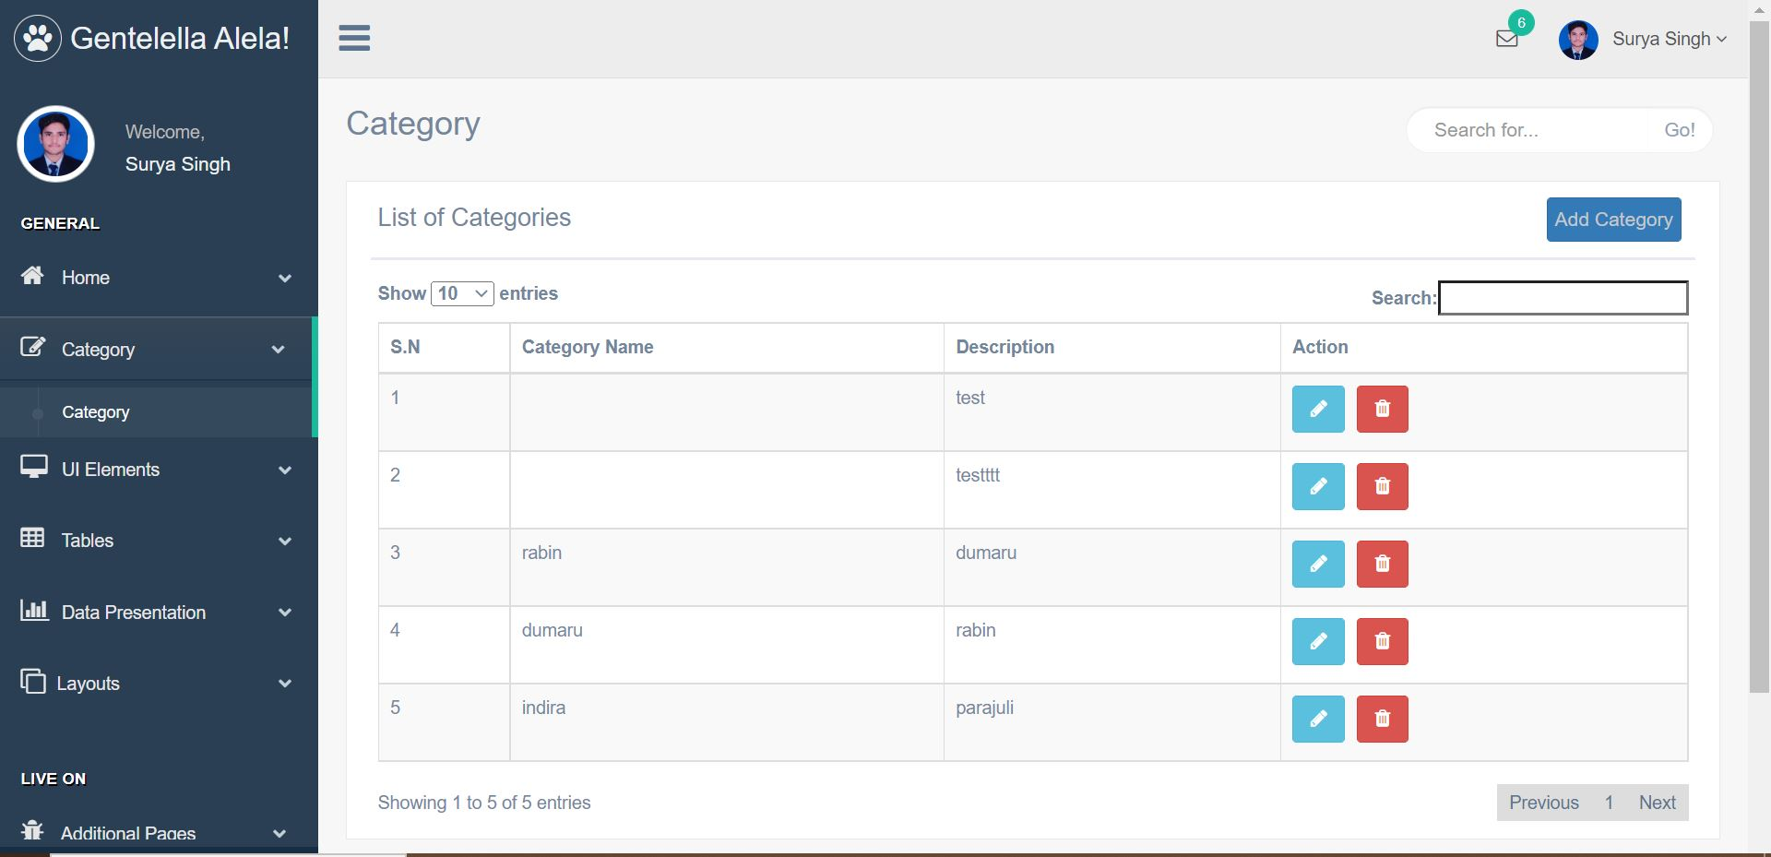

Figure 3.1‑34: Category List

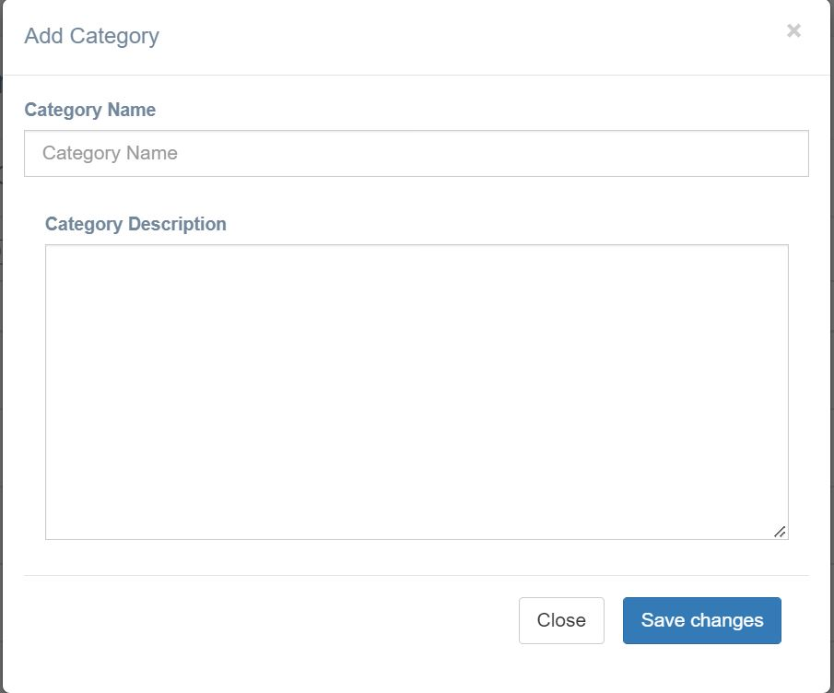

Figure 3.1‑35: Add Category Dialog

1. **GIT**

GitHub is a web-based version-control and collaboration platform for software developers.

**Git bash**

Git Bash is an application for Microsoft Windows environments which provides an emulation layer for a Git command line experience. Bash is an acronym for Bourne Again Shell. A shell is a terminal application used to interface with an operating system through written commands.

**Pull and Push**

Git push is a command used to upload local repository changes to a remote repository. git pull is a command used to download remote repository changes and integrate them with the local repository.

For example, suppose we have made some changes to a project locally, and we want to push those changes to the remote repository. We would first stage the changes to be committed, using the git add command, then use git commit to create a commit with your changes. Finally, we would use git push to upload the commit to the remote repository, which would then be available for other collaborators to access.

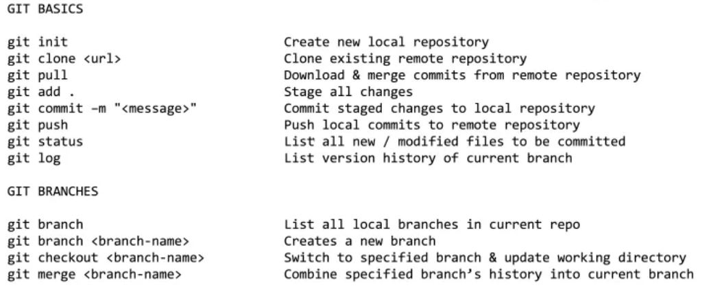On the other hand, if you want to incorporate changes that other people have made to the remote repository, we would use the git pull command. This command will download the changes from the remote repository and merge them with your local copy of the code, allowing us to work with the latest version of the project.

Figure 3.1‑36: Git Cheat Code

**Publish static page**

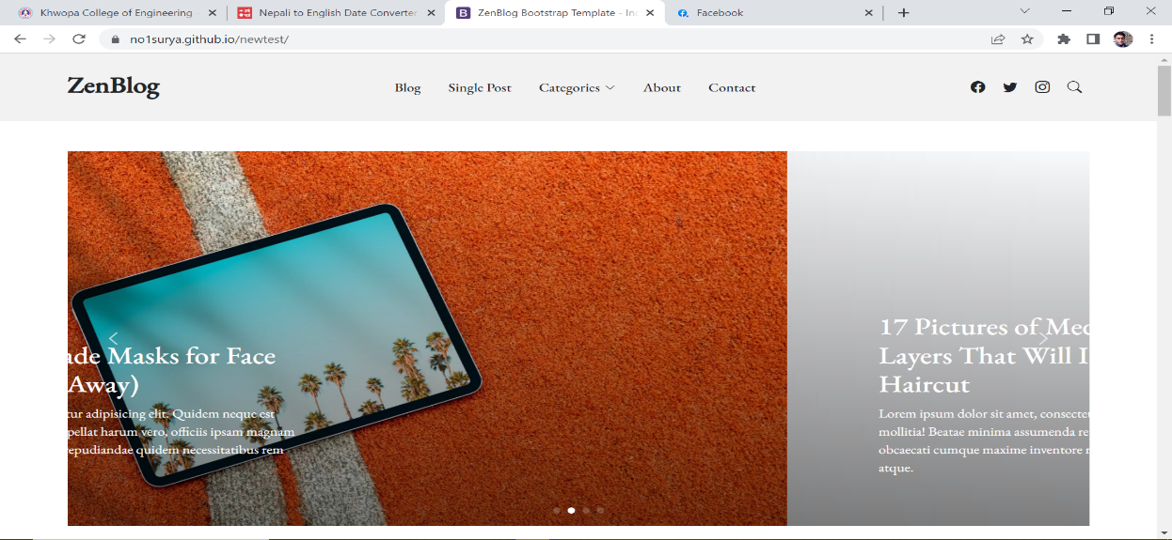To publish a static page on GitHub, we created a new repository on the GitHub website and then pushed static HTML files to the repository. In the next page, we selected the "Upload files" option and drag and drop our static HTML files into the upload area, or click the "Select your files" button to choose the files from your computer. Once files are uploaded, "Commit changes" button is clicked to save our changes to the repository. Our static HTML files will now be published on GitHub and we can access them by going to https://no1surya.github.io/newtest/.

Figure 3.1‑37: Static website

Overall, git push and git pull are important tools for collaborating on code projects using Git. They allow us to share your changes with others and incorporate the changes made by other collaborators, ensuring that everyone is working with the most up-to-date version of the code.

1. **Mathematics Session**

We covered about 40 marks of Mathematics course. For this, we discussed and planned to study the chapters that the OJT supervisor sir was comfortable with. All the resources were collected and chapters were carefully chosen.

Main chapters we learnt were: -

- Permutation and Combination (12 Marks)

- Probability (6 Marks)

- Linear Programming (4 Marks)

- System of Linear Equations (6 Marks)

- Numerical Integration (12 Marks)

We were made to study the chapters before the break time and at home. The teacher solved all the exercise questions one by one along with us and solved our queries. We could solve most of the questions from permutation & combination, probability and numerical integrations. Before Dashain, we covered almost 30 marks questions.

After Dashain vacation break, we resumed our OJT from 26th Ashoj. As we were running out of time, we had to hurry with the chapters to learn. On 26th, we revised all the topics we had covered so far and on 27th and 28th, we learnt about linear programming and system of linear equations.

On 30th, I appeared the back exam and I have passed the subject with C grade.

## Tasks Performed

OJT is a method of training in which new trainees are given hands on experience in the job they are performing. During our 6 months OJT, we performed tasks such as:

* Document Scanning
* QA testing of KhEC EMIS app
* Windows office installation and activation in computer lab
* Final Result Preparation
* Setup Router for IP camera & Installation of CN-Pilot Router
* Create Teams in MS-Teams for new Session
* Assist in IOE priority forms

1. **Document Scanning**

Document scanning is the process of converting paper documents into digital format using a scanner. Some tasks that we performed in document scanning include:

* Preparing documents for scanning by removing staples, paper clips, or other attachments
* Operating a mobile phone to capture images of the documents
* Checking scanned images for quality and clarity
* Performing data entry or indexing to make the scanned documents searchable
* Saving the scanned images in a specified file format
* Reviewing, editing and correcting errors in scanned documents
* Storing and organizing the scanned documents in a digital archive

We initiated the document scanning task by scanning the document from the batch 2076 to 2078. Each student document consists of mainly citizenship, slc result & character certificate, results of class 12 along with transcript and character certificate. We repeated this task for all departments i.e., Civil, Electrical and Computer.

Similarly, we collected old question and merge them into existing old question collection. We first scanned them properly with CamScanner and saved in laptop systematically i.e., on the basis of department and semester. And then, we merge the new scanned images into existing question collection pdf files. We collected old question of batch 2077 and 078, scanned them and converted into pdf documents and then finally merged into existing pdfs.

We scanned Letter Forwarded and Internal Letter Forward. Firstly, we collected the documents related to Internal Letter Forwarded and sort them in ascending order. After sorting, we started scanning them using CamScanner and stored them as per the letter consignment number. Similar tasks was performed for Letter Forwarding as well. Almost about 350 documents related to Letter Forwarding and 20 documents of Internal Letter Forwarding was scanned. The scanned files were then transferred to the computer and made ready to upload them into the EMIS system. We were first guided about the EMIS system new feature of uploading Letter Forwarded and Letter Registration to upload them properly.

With the letter consignment no. 1, we started uploading them. We had to upload the file and then enter the details such as letter subject, letter date, receiver name, and so on. Snippet of internal letter forwarding is shown below:

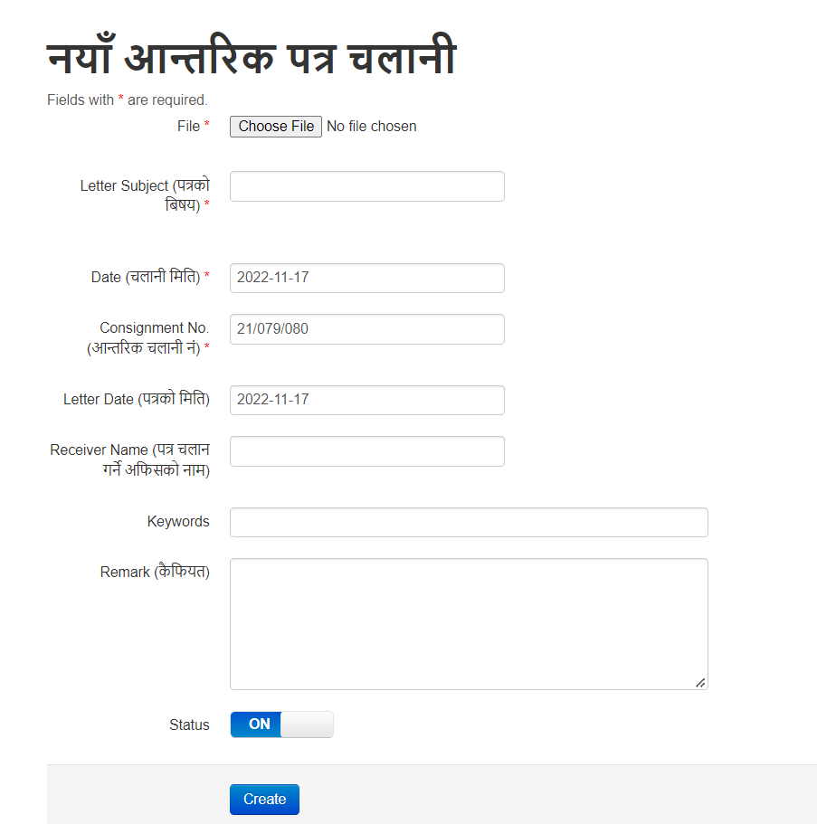

Figure 3.2‑1: Letter Forwarding

Similar activities were performed for Letter Forwarding (kq rnfg). Total of 145 records (20 Internal Letter Forwarding (cfGtl/s kq rnfgL) and 125 Letter Forwarding (kq rnfgL) have been uploaded into the EMIS section.

We uploaded the letter into the EMIS with all necessary data like Reg_date, letter_date, letter_subject, order_subect, and so on. Total of 73 registered letters have been uploaded into the EMIS system.

1. **QA testing of KhEC EMIS app**

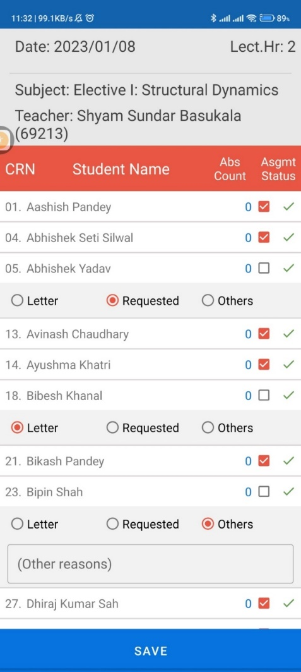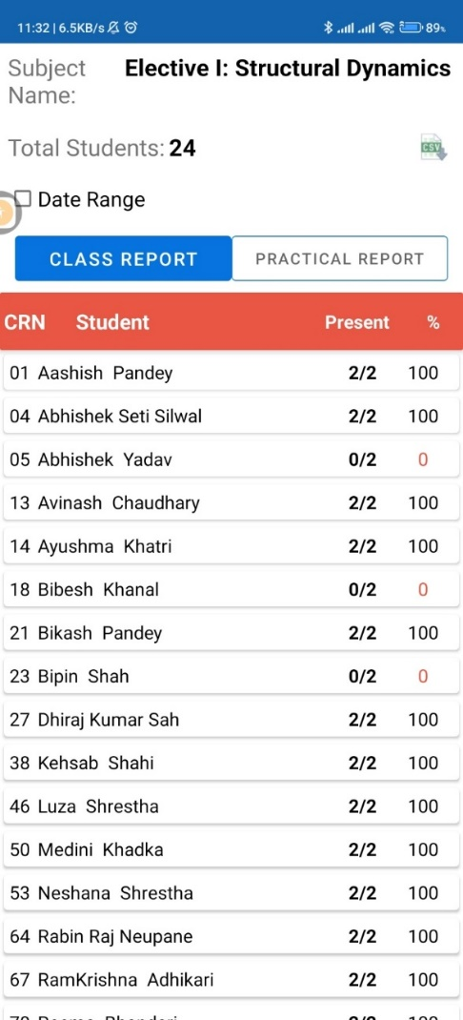We also tested the KhEC EMIS app. I had to take attendance on various subject and monitor the result to check its accuracy. We then tested the KhEC EMIS app after the app was published on google play store. We had to check if all the functionalities were working properly and report the bugs. Attendance of various subjects were taken and checked its result for accuracy. We also checked if the documents were downloading in different devices.

Figure 3.2‑2: Attendance Taking

Figure 3.2‑3: Attendance check

1. **Windows office installation and activation in computer lab**

We were mostly involved in installing different software’s (MATLAB, Proteus, MS Office, Photoshop, Auto cad, Lumion, Safe, ETABS etc.) in computer lab. We installed and removed different programs and files. We also learnt to create bootable USB and then install windows and office packages.

We were actively involved in installing different software in the Block F & G computer lab. We used KMSpico to active office and windows in no. of computers as previous activation had expired. We even installed Ubuntu OS (dual boot) in some computers as well.

1. **Final Result Preparation and Scholarship data import in MIS**

Firstly, we managed all the regular exam results from 2066 to 2078. Our task was to include subject code as per the EMIS to all the subjects in the results. We had to apply different formulas to work around the elective subject. It was a real test to our knowledge in the excel. After completing regular results, we switched to back exam results. Managing back exam results was too troublesome as most of the semester had 12 back exams and managing them with subject code consumed lots of time.

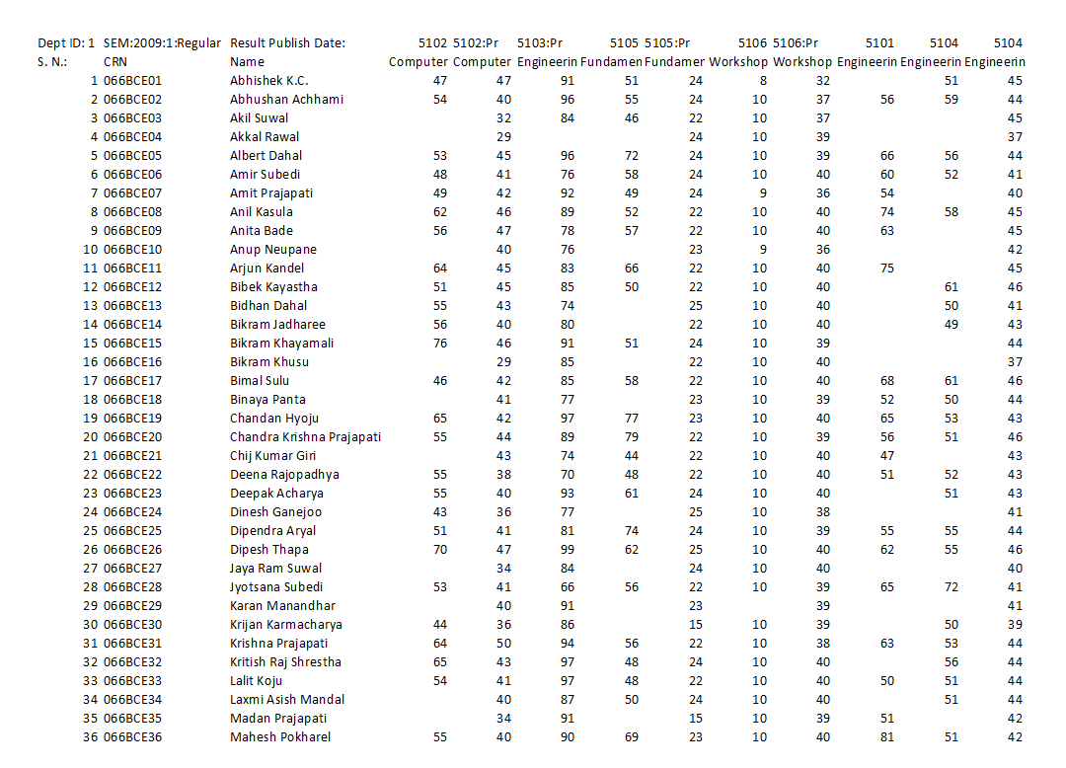Another task performed was to manage the scholarship data to upload into MIS. For this, we searched website notices and collected all the data regarding scholarship i.e., entrance topper, semester topper and needy & diligent student scholarship. After collecting scholarship related notices, all the data were manually entered into the Excel files and then uploaded into the MIS.

Figure 3.2‑4: Final Result Preparation

1. **Setup Router for IP camera & Installation of CN-Pilot Router**

We even worked on the IP camera of F & G block. We took two router devices, one as server and another as client. Server router is fixed on ceiling and client router is attached at the top of lift and connected with the camera within the lift. We took two router devices, one as server and another as client. Server router is fixed on ceiling and client router is attached at the top of lift and connected with the camera within the lift. We were also involved in installing the CN pilot router in Block A and Block C. We had to export the pre-config file from our already installed routers and import it into all new routers. Then we updated the IP address in each router as supervised, plant the routers in required position and then finally RJ 45 connected to them.

1. **Create Teams in MS-Teams for new Session**

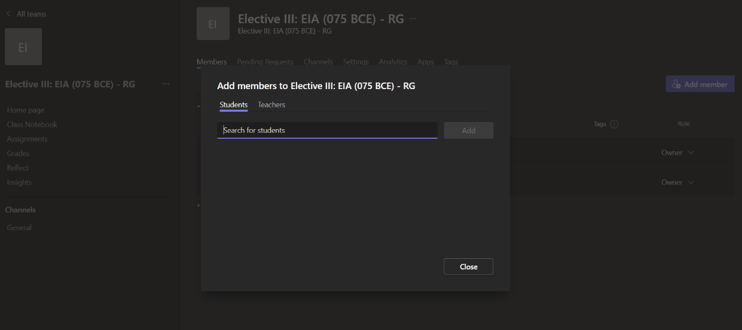We were first guided by the supervisor sir about the teams and the process of creating teams. While creating first few teams, the teacher monitored us and when we were ready to create teams on our own, we were given the login credentials and all the details of the courses and their respective teachers. As all the templates were already prepared by the sir prior, we created the teams with ease.

Figure 3.2‑5: Create Teams

1. **Assist in IOE Priority Forms**

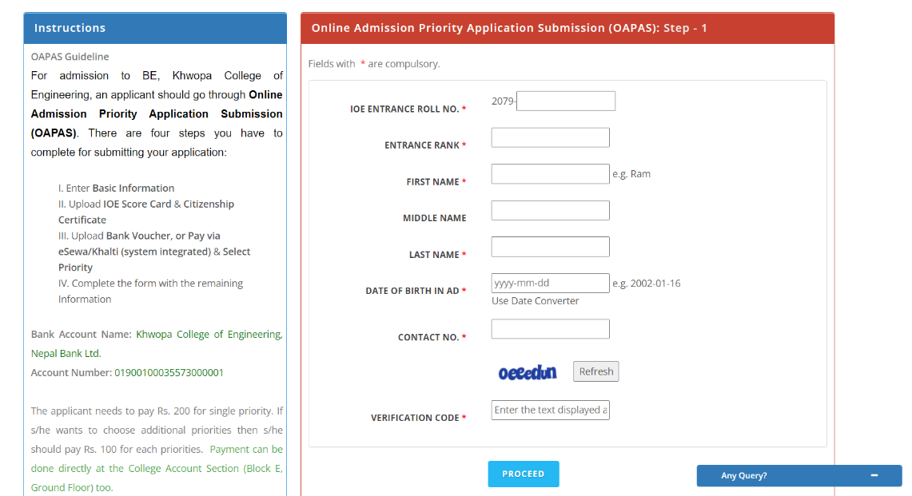We were taught about the IOE priority form submission. We discussed about it thoroughly and practiced it by submitting form in local rather than live server. From 20th Mangsir, we started guiding students who came to fill the priority form in college.

Figure 3.2‑6: Priority form

# Conclusion and Recommendations

## Conclusion

My six-month OJT experience has been an extremely valuable learning opportunity. I have gained a wealth of knowledge and practical skills in my field, and I am confident that these will serve me well in my future career.

During my training, I was able to work on real-world project and collaborate with experienced professionals, which helped me to understand the practical application of the theories I had learned in school. I also had the opportunity to learn new technologies and tools that are currently being used. I had the opportunity to sharpen my skill on database, PHP coding and certain portion of GIT.

Overall, I would like to express my appreciation to the college for providing me with this opportunity, and to my supervisors for their guidance and support throughout the training period. I would also like to suggest that in future, the college should work on providing more hands-on training on the latest technologies, and also more interaction with other trainees to share ideas and knowledge.

In summary, my OJT experience has been an extremely valuable one, and I am confident that it will serve as a strong foundation for my future career.

## Recommendations

Experience is the best learning tool for me after my OJT. This served as my steppingstone to pursue my dream to be a Registered Computer Engineer. This training gave me an inspiration to be more serious and focused on my studies. I viewed my OJT experience as a meaningful one despite the short period of time. The training enriched my confidence to become a good employee someday. It inspired me to be more determined and competitive in everything that I do in my daily life as a student today and as a professional someday.

All I can say to the incoming OJT student is to always remember to have discipline and to uphold moral standards at work. Take OJT as a serious matter because this will really help them in the future. Always respect your supervisors and do everything they say. Follow the rules and be polite. Always arrive before the start of your work to impress your supervisors. Having these qualities will lead to a successful and meaningful OJT experience.

# Appendix

Appendix 1: Worksheet of Shrawan month

|  |  |  |
| --- | --- | --- |
| **SN** | **Task Performed** | **Trainings** |
| 1. | Document Scanning  - Checked all the documents of batch 2077 & 2078 and ensured all documents were present. | Microsoft Word   * Basics of Word * Formatting, Structures, Referencing etc. * Mail Merge (ex. ID Card) |
| 2. | QA testing of KhEC EMIS app | Microsoft Excel   * Basics of Excel * Conditional Formatting (ex. If, VLOOKUP, concatenate, proper etc.) * Filters, Charts |
| 3. | Windows office installation and activation in computer lab | Microsoft PowerPoint  - Basics of PowerPoint |
| 4. | Installation and Removal of programs and other files in computer lab | Cisco design   * IP Dhcp pool * Vlan * Inter Vlan Routing * Telnet * Dns-Server * Static Ip address |
| 5. | Final Result Preparation  - Batch 2066 to Batch 2078 (Regular and back) | RJ-45 Ethernet cable connection  Shared file by using IP address in same network |
| 6. |  | Google Form  - Basics of google form and data collection |

Appendix 2: Worksheet of Bhadra month

|  |  |  |
| --- | --- | --- |
| **SN** | **Task Performed** | **Trainings/Lessons** |
| 1. | Final Result Preparation   * Batch 2076 and 2077 (Back Continue) * Regular Exam   (2075 & 076 4th Sem and 6th Sem) | Database Design and Different Operations   * Introduction to database * Database Creation * Table Creation and Relations Between different tables * CRUD Operation * SQL Query   (Select, Insert, Update, Delete)   * Join (Inner Join, Outer Join, Left Join, Right Join) * Sub Query (Basic) * Aggregate Functions   (MAX, MIN, SUM) |
| 2. | Setup Router for IP camera   * Server * Client | Cisco design   * Dynamic RIP * DHCP * Static |
| 3. | QA testing of KhEC EMIS app | Mathematics Practice for class 12 back exam |
| 4. | Scholarship Data Collect and Manage for EMIS. |  |
| 5. | Document Scanning   * Old Question Collect, Scan & Update to existing pdf files |  |

Appendix 3: Worksheet of Ashoj month

|  |  |  |
| --- | --- | --- |
| SN | Task Performed | Trainings/Lessons |
| 1. | Document Scanning  - Old Question Collect, Scan | Mathematics Practice for class 12 back exam   * Permutation and Combination * Statistics * Probability * Linear Programming * System of Linear Equations * Numerical Integration |
| 2. | Router setup for IP camera (Block E lift) | Cisco design (Revision)  - Dynamic RIP  - IP Dhcp pool  - Dns-Server |

Appendix 4: Worksheet of Kartik month

|  |  |  |
| --- | --- | --- |
| **SN** | **Task Performed** | **Trainings/Lessons** |
| 1. | Document Scanning  - Old Question Collect, Scan.  - Letter Forwarded (kq rnfgL).  - Internal Letter Forwarded (cfGtl/s kq rnfgL) and Upload To EMIS System. | Basic Php   1. Php overview 2. Xampp Installation 3. Php Basic Part I  * Php Syntax, * Variables, Echo and Print * Data types   String, Integer, Character, Constant   1. Operator, Conditional Statement. 2. Php Basic Part II  * Loop, Function, Array & its types, Supper Global Variable, Datetime.  1. Session & Cookie 2. Exception Handling 3. Database and MySQL |
| 2. | Installation of CN-Pilot Router in Block A. |  |
| 3. | Create Teams in MS-Teams for new Session. |  |
| 4. | Software installations in lab. |  |

Appendix 5: Worksheet of Mangsir month

|  |  |  |
| --- | --- | --- |
| **SN** | **Task Performed** | **Trainings/Lessons** |
| 1. | Document Scanning  - Letter registration (kq btf{)  and Upload to EMIS System. | GitHub   * Git bash * Pull * Push * Publish static website * Project file configuration |
| 2. | Active Office & Windows in lab. | Dashboard Cleaning and Project |
| 3. | Assist in IOE priority forms. | Basic Php   * Folder Configuration * Database Module * Database module generate SQL * Session Login. |